**A Project Report**

**On**

**"SPORTS SCORESHEET ORGANIZER"**

Submitted in Partial Fulfillment of the Requirement Of

Project-I (BIT106CO)

Of

Bachelor of Information Technology

**Submitted to:**



Purbanchal University

Biratnagar, Nepal

**Submitted by:**

Sagar Upadhyaya (313346)

Shubham Ghimire (313348)

Dhiraj Sapkota (313326)

**KANTIPUT CITY COLLEGE**

Putalisadak, Kathmandu

November 21, 2021

**A Project Report**

**On**

**“SPORTS SCORESHEET ORGANIZER”**

Submitted in Partial Fulfillment of the Requirement Of

Project I-(BIT106CO)

Of

Bachelor of Information Technology

**Submitted to:**

Purbanchal University

Biratnagar, Nepal

**Submitted by:**

Sagar Upadhyaya (313346)

Shubham Ghimire (313348)

Dhiraj Sapkota (313326)

**Project Supervisor**

**Ashim Kc**

**Program Coordinator**

**KANTIPUT CITY COLLEGE**

Putalisadak, Kathmandu

November 21, 2021

**CERTIFICATE OF TOPIC APPROVAL SHEET**

It is here by informed that the topic selected by Sagar Upadhyaya, Shubham Ghimire, and Dhiraj Sapkota of BIT First semester project has been found suitable and as per the credit assigned by Purbanchal University (PU), Biratnagar, Nepal. The Project Committee has approved the following topic and supervisor for the mentioned students. This project has been completed for the prescribed period and the project embodied the result of their investigation conducted during they worked as full-time student of this institution.

Topic Approved: Sports Scoresheet Organizer

_____________________ ______________________

Mr. Saroj Pandey Mr. Ashim Kc

Deputy HOD, Department of Information Technology Project Supervisor

Kantipur City College Kantipur City College

**CERTIFICATE FROM SUPERVISOR**

This is to certify that the project titled “Sports Scoresheet Organizer” submitted by Sagar Upadhyaya, Shubham Ghimire, and Dhiraj Sapkota to the Department of Information Technology, School of Science and Technology at Kantipur City College, Kathmandu, Nepal towards the requirement for Project-I (BIT106CO) is an original work carried out by them under my supervision and guidance.

____________________

Ashim Kc

Department of Information Technology

Kantipur City College

(Project Supervisor)

**ACKNOWLEDGEMENT**

We would like to acknowledge all who have encouraged and inspired us directly or indirectly to complete this project. At first we desire to express our deepest sense of gratitude to Purbanchal University for giving us the opportunity to present ourselves this report within the scheduled time.

We want to thank Kantipur City College for providing this opportunity by approving our project. We are very grateful to our supervisor Mr. Ashim Kc for continuously supporting and guiding us in our project and providing his valuable time to complete our project.

We also are very thankful to Mr Bikash Neupane who was also helpful for providing us the idea to prepare this project and for continuously motivating us to focus towards our project.

We are fortunate enough to get the encouragement and feedback from our teachers and friends. Lastly, many thanks to all the people for their suggestions, feedback and support which was the most in completing our project successfully.

This project has been a wonderful experience where we have learnt and experienced many beneficial things.

With regards

Sagar Upadhyaya

Shubham Ghimire

Dhiraj Sapkota

**ABSTRACT**

Maintaining Scoresheet of the games using software can be the best way to practice for accessing and entering essential data and information required. So, such kind of project is Sports Scoresheet Organizer which we built using the C programming language that can be useful to record or store data regarding the Scoresheet information of the games: cricket and football. Sports Scoresheet Organizer can be used for maintaining such kinds of games detail as it will increase the efficiency and smoothness of the program and help user to enter the data at run time during the games.

This project report on Sports Scoresheet Organizer consists of background and significance of the project with objectives, features and problem solving statement of the project which shows the detail information about the research done about existing system and limitation of them and its working mechanism with proper functionality. And we are hopeful that this project (Sports Scoresheet Organizer) might be helpful for most of the users who desire for maintaining systematic record of the scoresheet of the games (Cricket and Football).

**LIST OF TABLE**

|  |  |  |
| --- | --- | --- |
| **Table no.** | **Table name** | **Page no.** |
| 1 | Team Structure and Role | 11 |
| 2 | Functional Requirement | 15 |
| 3 | Data Structure | 16 |
| 4 | Requirement Gathering Process | 12 |

# **ABBREVATIONS**

* SSO: Sports Scoresheet Organizer
* HDD: Hard Disk Drive
* IDE: Integrated Development Environment
* RAM: Random Access Memory
* GUI: Graphical User Interface

**TABLE OF CONTENT**

**Table of Contents**

**ACKNOWLEDGEMENT5**

**ABSTRACT6**

**LIST OF TABLES7**

**ABBREVATIONS7**

**Chapter 1: Introduction**10

1.1 Project background10

1.2 Project significance10

1.3 Problem solving statements10

1.4 Project objectives11

1.5 Project features11

1.6 Team structure and roles11

**Chapter 2: system Analysis12**

2.1 Literature Review12

2.1.1 Limitation of Existing projects12

2.2 Requirement gathering process12

2.3 Feasibility study13

2.3.1 Technical feasibility13

2.3.2 Economic feasibility 13

2.3.3 Operational feasibility 13

2.3.4 schedule feasibility 13

**Chapter 3: system design14**

3.1 Functional analysis14

3.1.1 Header files15

3.1.2 User defined functions16

3.1.3 Structure type16

3.2 Algorithm16-20

3.3 Flowchart21-24

**Chapter 4: System Development And Implementation25**

4.1 programing platform(Tools and technology used)25

4.1.1 software specification25

4.1.2 Hardware specification25

**Chapter 5: Conclusion and future enhancement26**

5.1 conclusion26

5.2 Future enhancement26

**REFERENCES27**

**APPENDIXES28**

**APPENDIXES** 128

1.1 Main menu_128

1.2 Menu_228

1.3 table Game details29

1.4 players details29

1.5 Scoresheet_130

1.6 Scoresheet_230

1.7 Match Summary31

**APPENDIXES** 232

2.1 Gantt chart32

**CHAPTER 1: INTRODUCTION**

* 1. **Project Background**

Maintaining Scoresheet of the games without using system creates a lot of problem in data entry, data update as well as data access. So, we built up the system that can be best use for maintaining scoresheet of the games. Sports Scoresheet Organizer is the project that is built for the systematic maintenance of the scoresheet during the games i.e. Cricket and Football. For e.g.: this program can create and display the scoresheet which includes the match detail such as total runs, total wickets, names of batsmen and bowlers, overs, extras, etc. in case of cricket. Similarly, different records such as total goals, fowls, saved, assist, time, names of player and their respective position, etc. in case of football.

The interface of this project is quite easy to interact as this project is coded in user understandable form. This system consists of different functions and also has menu options which are easily understandable by the users. As the program name itself describes, it is a system with availability of multiple features where user can create, search, modify, update and view different records of the game.

This system also has a security function so that only authorized individuals can operate it. The above details provide a little background of the system which is the purpose of this report.

* 1. **Project Significance**

This project is mainly concerned with making an application using the C programming language and the main significance of this project is to help understand the use of C programming language and as a medium to make the imagination of any programmer into the reality.

* 1. **Problem Solving Statement**

Sports Scoresheet Organizer provides the platform to the user where they can create, search, modify, update and view different records of the game. This project provides user the ability to create file in order to store different records of football and cricket scoresheet and can search the file records with the help of file code.

* 1. **Project Objectives**
* To provide user the ability to create cricket and football scoresheet
* To provide user the ability to modify scoresheet records
* To provide user the ability to view existing scoresheet records
  1. **Project Features**
* Access to create, modify and view scoresheet records
* Access of match info regarding games
* Records are specified separately
* Program stores each player's record
* Password protection

**1.6 Team Structure and Role**

|  |  |
| --- | --- |
| **Team Members** | **Task Performed** |
| Sagar Upadhyaya | Coding, documentation, design, debugging & research |
| Shubham Ghimire | Logic development, documentation, design, debugging |
| Dhiraj Sapkota | Coding, documentation, debugging, research & analysis |

**CHAPATER 2: SYSTEM ANALYSIS**

**2.1 Literature review**

Creating and Maintaining the Sports Scoresheet in simple paper based format was in practice since early time. But with the change in time and technology the system of record keeping was digitalized and creating and maintaining the records has become much more efficient and more easily accessible.

During our research we found some scoresheet related project that has already been developed like mini project on cricket scoresheet. But those project were lacking features like different games detail such as: format of the game, venue, wickets, no of balls, all players record etc. The interface of the project wasn’t user friendly and this system also lacked security function. Likewise, those project didn’t have the feature to edit and view records. Hence, we included all the mentioned features in our program “**Sports Scoresheet Organizer**”.

**2.1.1 Limitation of existing system**

* Can only be operated by single user
* No graphical user interface (GUI)

**2.2 Requirement gathering process**

|  |  |  |  |
| --- | --- | --- | --- |
| **Requirement No.** | **Requirement Name** | **Requirement description** | **Function Number** |
| 1. | password | To make Sports Scoresheet Organizer secure | 1 |
| 2 | create | To create new scoresheet record | 2 |
| 3 | display | To display existing scoresheet record | 3 |
| 4 | Edit | To edit details of the Scoresheet | 4 |

**2.3 Feasibility study:**

In a feasible study we performed feasibility analysis of a current system and the proposed system. Feasibility study is done to identify the deficiencies in the current system and find the objective of the proposed system. There are many types of study that needs to be consider but following are the major study we performed while developing this project.

**2.3.1 Technical Feasibility**

Here we analyze the technical aspects of the project. The various technical aspects such as hardware and software were taken into consideration while developing this project.

Further we also make sure that this software is feasible for the person who uses it.

**2.3.2 Economic Feasibility**

Here we deal with the cost benefit of the project. Since this project is developed to meet our academic project, therefore there is no any refund.

**2.3.3 Operational Feasibility**

We develop this project with the minimum specification computer so that it will go long lasting because of low cost and reliable.

The user will enjoy with this system which is easy to understand and operate by few instructions.

**2.3.4 Schedule Feasibility**

In this feasibility study we prepared our planned Gantt chart according to our development model.

**CHAPTER 3: SYSTEM DESIGN**

**3.1 Functional Analysis**

This system contains different functions, header files that helps in running our project. All the header files and functions used in our project are given below along with their characteristics and descriptions:

**3.1.1 Header Files**

|  |  |
| --- | --- |
| **Header file** | **Description** |
| #include<stdio.h> | All standard library functions for file input and output are included on stdio.h |
| #include<conio.h> | All console input/output functions are included in conio.h |
| #include<time.h> | time.h provides various functions for manipulating date and time. |
| #include<graphics.h> | All graphical functions are included on graphics.h |
| #include<dos.h> | dos.h header file provide us easy access to use function for date and time. |
| #include<math.h> | math.h contains function for handling different mathematical operation. |
| #include<string.h> | string.h contains function for handling string operations. |

**3.2.1 User Defined functions**

|  |  |
| --- | --- |
| **User Defined Functions** | **Description** |
| char opening(); | To login SSO |
| void Home(); | To display menu for create, browse and exit |
| void create(); | To display menu for creating cricket/football |
| void browse(); | To display menu for browsing cricket/football |
| void cricketscore(); | To display continue/back for creating cricket scoresheet |
| void create_cricketsheet1(); | To create cricket scoresheet game details |
| Edit_matchdetail(); | To edit game details of scoresheet |
| void footballscore(); | To display continue/back for creating football scoresheet |
| void create_footballsheet1(); | To create football scoresheet game details |
| void view_cricketscore(); | To display continue/back for viewing cricket scoresheet |
| void view_footballscore(); | To display continue/back for viewing football scoresheet |
| void browse_cricket(); | To provide the user access of browsing cricket files |
| void browse_football(); | To provide the user access of browsing football files |
| void Cricket(); | To ask file name to view cricket scoresheet game details |
| void Football(); | To ask file name to view football scoresheet game details |
| void C_Players_detail_team1(); | To create cricket scoresheet player details team 1 |
| void C_Players_detail_team2(); | To create cricket scoresheet player details team 2 |
| void F_Players_detail_team1(); | To create football scoresheet player details team 1 |
| Void F_Players_detail_team2(); | To create football scoresheet player details team 2 |
| void Cricket_display(); | To view cricket scoresheet game details |
| void C_Player_det1(); | To view cricket scoresheet player details team 1 |
| void C_Player_det2(); | To view cricket scoresheet player details team 2 |
| void Football_display(); | To view football scoresheet game details |
| void F_Player_det1(); | To view football scoresheet player details team 1 |
| void F_Player_det2(); | To view football scoresheet player details team 2 |
| void C_scoresheet(); | To ask user which team has won the toss for cricketsheet_1 |
| void V_C_scoresheet(); | To ask user which team has won the toss for cricket to view scoresheet |
| void C_team1(); | To choose decision bat/ball for cricket to create scoresheet_1 |
| void V_C_team1(); | To choose decision bat/ball for cricket to view scoresheet_1 |
| void C_team2(); | To choose decision bat/ball for cricket to create scoresheet_2 |
| void V_C_team2(); | To choose decision bat/ball for cricket to view scoresheet_2 |
| void Bat_inning1(); | To create scoresheet record of first inning batting_1 |
| void Ball_inning1(); | To create scoresheet record of first inning balling_1 |
| void First_inning_bat(); | To create scoresheet record of second inning batting_1 |
| void First_inning_ball(); | To create scoresheet record of second inning balling_1 |
| void inning_second_bat(); | To create scoresheet record of first inning batting_2 |
| void inning_second_ball(); | To create scoresheet record of first inning balling_2 |
| void Second_inning_bat(); | To create scoresheet record of second inning balling_2 |
| void Second_inning_ball(); | To create scoresheet record of second inning balling_2 |

**3.3 Data Structure**

|  |  |
| --- | --- |
| **Structure Type** | **Data Type** |
| C1 | int, char, char[] |
| F1 | int, char, char[] |
| P1 | int, char, char[] |
| P2 | int, char, char[] |
| P3 | int, char, char[] |
| P4 | int, char, char[] |
| P5 | int, char, char[] |
| P6 | int, char, char[] |
| Q1 | int, char, char[] |
| Q2 | int, char, char[] |
| Q3 | int, char, char[] |
| Q4 | int, char, char[] |

* 1. **Algorithm**

Step 1: Start

Step 2: Display Opening Interface.

Step 2: Input password

Step 3: IF password is true then goto step 4

otherwise display “Incorrect password please enter again” goto step 2

Step 4: Display Home page: choose

1. **Create**
2. **Browse**
3. **Quit**

Step 5: if user choose 1 then display:

Enter a file name...............

Else if choose 2 go to step 49

Else terminate the program

Step 6: Display and choose

1. cricket

2. football

Step 7: If user choose 1 goto step 8 else if goto step 28 else goto step 4

Step 8: Display the table 1.1 (Details)

Step 9: Input cricket league (multiple choice)

Step 10: Input the number of over (for international games like ipl, world cup will be displayed according to league chosen.

Step 11: Input venue, date of match, name of teams (command for inputting real time date

Step 12: Input total no. of players in each team including substitution

Step 13: Display

1. continue
2. edit
3. back

Step 14: if user choose 1 then display **goto step 15**

else if user choose 2 then enable editing

else goto step 4

Step 15: Display table for team 1

Step 16: Input JN, name, position of the player

Step 17: Display table for team 2

Step 18: Input JN, name, position of the player

Step 19: Display toss won by:

1.team 1

2.team 2

and choose(bat/ball) by toss winner

Step 20: Display "title", **First Inning**

Step 21: input a file name for first inning batting team and Display table for first inning

Step 22: Display JN and name of each player and input run made by each player

Step 23: Input file name for first inning bowling team

Step 24: Display JN and name of players of bowling team

Step 25: input wicket taken and run given by each player

Step 26: display total wicket taken and total run given

Step 27: input total extra run given from misconducts

Step 28: display total run scored in the first inning and target run

Step 29: input a file name for first inning batting team and Display table for second inning

Step 30: Display Jn and name of each player and input run made by each player

Step 31: Input file name for second inning bowling team

Step 32: Display JN and name of players of bowling team

Step 33: input wicket taken and run given by each player

Step 34: display total wicket taken and total run given

Step 35: input total extra run given from misconducts

Step 36: Display result

**Soccer scoresheet**

Step 38: Display "title - **Soccer scoresheet**" the table 1.2(Details)

Step 39: Input football league (multiple choice)

Step 40: Input venue, date of match, name of teams (command for inputting real time date

Step 41: Input coach name of each team

Step 42: Input total no. of players in each team including substitution

Step 43: Display

1. continue
2. edit
3. back

Step 44: if user choose 1 goto step 45

Else if user choses 2 goto step 39

Else go to step 4

Step 45: Display table for team 1 and input players #JN, name, position of respective team

Step 46: Display table for team 2 and input players $JN, name, position respective team

Step 47: input file name for team 1’s football score

Step 48: Display JN and name of each players

Step 48: input total shoot and total goal by each player

Step 49: input total misconduct

Step 50: input total saves and total assist

Step 51: Display total shoot made and total goals by team 1

Step 52: input file name for team 2’s football score

Step 53: Display JN and name of each players

Step 54: input total shoot and total goal by each player

Step 55: input total misconduct

Step 56: input total saves and total assist

Step 57: Display total shoot made and total goals by team 2

Step 58: Display result

**Browse**

Step 59: Display

1.cricket 2. Football

Step 60: If user choses 1 goto step 61

Else goto step 74

Step 61: display the first table for details of match

Step 62: display the second table for first team jersey number, name and position of each players

Step 63: display the table of second team jersey number, name and position of each players

Step 64: Display the table of first inning for both batting team and blowing team.

Step 65: Display wicket taken and run given by each player

Step 66: display total wicket taken and total run given

Step 67: Display total extra run given from misconducts

Step 68: display total run scored in the first inning and target run

Step 69: display the table for second inning for both batting and lowing team

Step 70: Display wicket taken and run given by each player

Step 71: display total wicket taken and total run given

Step 72: input total extra run given from misconducts

Step 73: Display result

**Display Soccer scoresheet**

Step 74: Input file name to display match detail

Step 75: display the first table for details of match

Step 76: input file name to display player detail of team 1

Step 77: display the table for first team jersey number, name and position of each players

Step 78: input file name to display player detail of team 2

Step 79: display the table of second team jersey number, name and position of each players

Step 80: input file name for team 1’s football score

Step 81: display JN and name of each players

Step 82: display total shoot and total goal by each player

Step 83: display total misconduct

Step 84: display total saves and total assist

Step 85: Display total shoot made and total goals by team 1

Step 86: display file name for team 2’s football score

Step 87: Display JN and name of each players

Step 88: display total shoot and total goal by each player

Step 89: display total misconduct

Step 90: display total saves and total assist

Step 91: Display total shoot made and total goals by team 2

Step 92: Display result

Step 93: goto step 4

Step 94: End

**3.3 Flowchart**

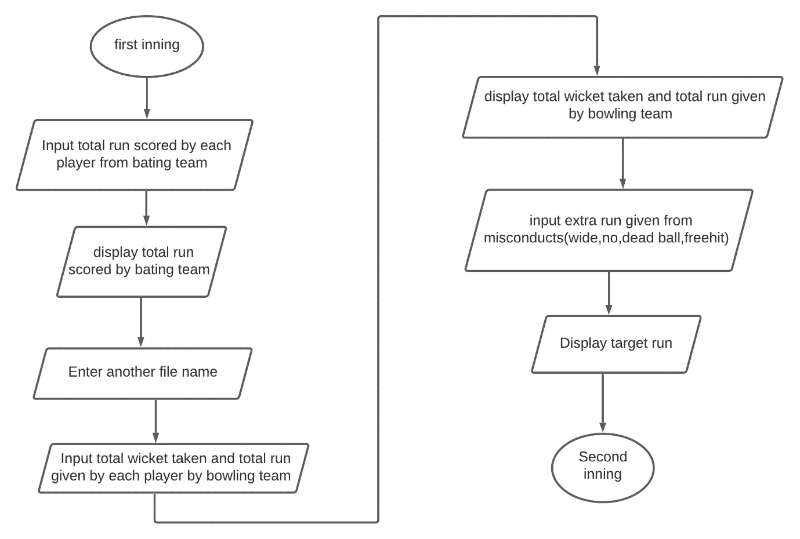

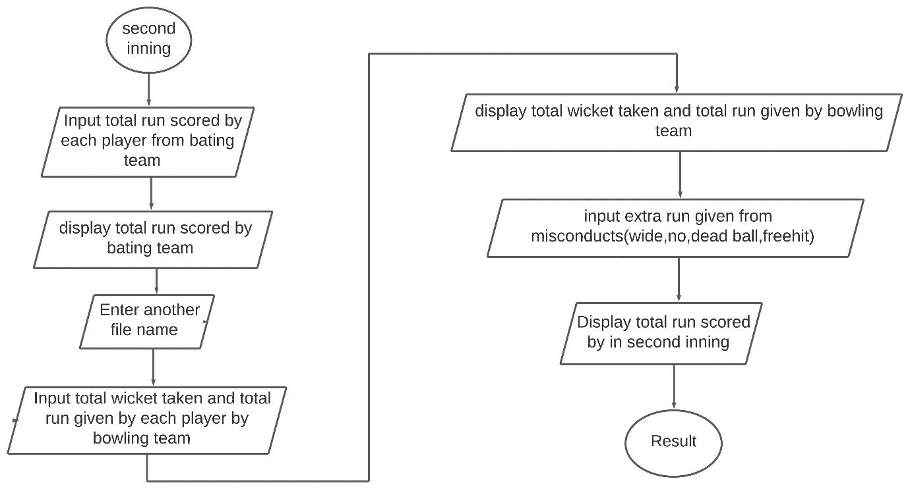

# 

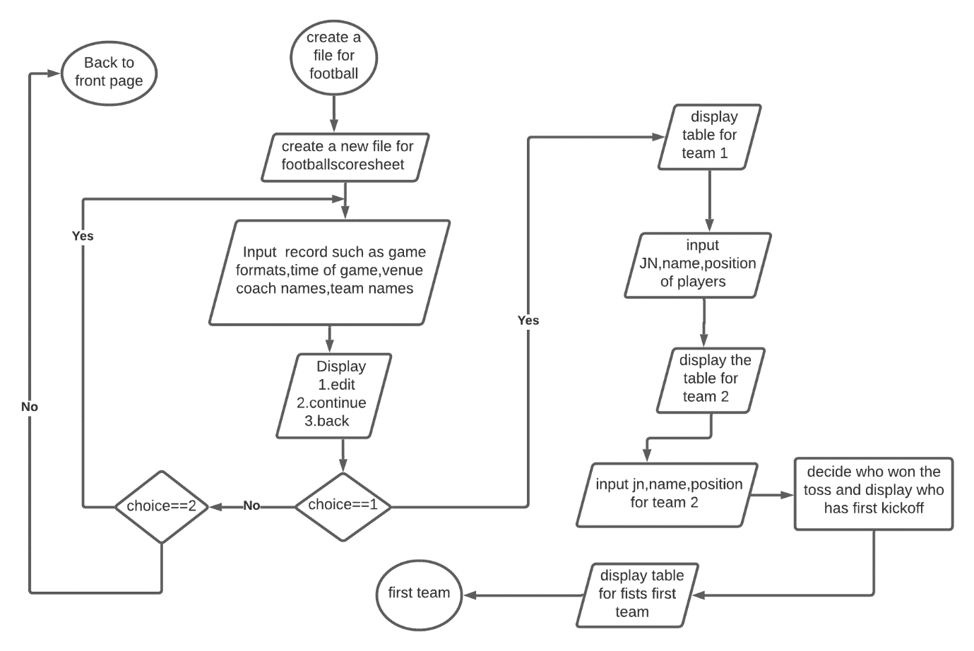

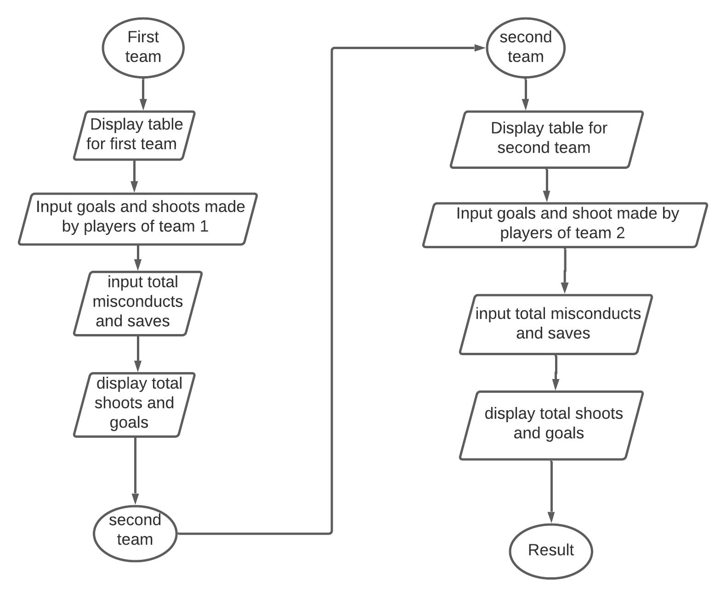

# **Chapter 4: System Development and Implementation**

## 

**4.1 Programing platform (Tools and technologies used)**

**4.4.1 Software Specifications**

Computer software specification we have used for development:

* Operating System: Windows 10 Operating System
* IDE: Dev C++ 5.11 / turbo C++
* Programming Language: C

**4.1.2 Hardware Specifications**

Computer hardware specification we have used for development:

* Processor: core-i7
* RAM: 8GB
* HDD: 1 TB

**CHAPTER 5: CONCLUSION AND FUTURE ENHANCEMENT**

**5.1 Conclusion**

In this documentation we have tried to explained each and every individual's topic clearly as per our project. As this was the first time of doing this kind of project it was difficult to us but we gained new skills which will be helpful to our future project and career. This project was really helpful to us in gaining experience of using c programming.

As we know that no any program can be 100% reliable and efficient. So there are also some drawbacks from our system like it cannot perform all the required function as of professional one. It’s simply a scoresheet record keeping system of cricket and football. It is actually a user-friendly as it is easy to use by just following the instructions which are appeared on the screen. And actually file input name should have matched the name entered already in the system in order to view the records.

Some of the important things we learned from this project:

1. We learned to use file handling functions where we were able to create, update, view the records in the file.
2. We learned to draw different shapes with the help of graphics.
3. We learned to use both library as well as user defined functions along with their importance.
4. We learned to keep record of the data using structure and so on.

**5.3 Future enhancement**

* Interactive user interface
* GUI based program

**REFERENCES**

Abiral, B(29 June, 2011). Project on c programming. Retrieved July 2, 2021 from <https://www.scribd.com/document/58979208/Project-on-C-programming>

Sasidhar.K(16 Sep, 2014). Mini project on c. Retrieved July 22, 2021 from <https://www.amfastech.com/2014/09/10-miniprojects-inc-with-source-code.html>

Tutorials points (Jan 4,2015). C tutorial. Retrieved Aug 10, 2021 from <https://www.tutorialspoint.com/cprogramming/index.htm>

Jaydeep.D(n.d) 50+ interesting c project. Retrieved Aug 02, 2021 from <https://learnprogramo.com/50-interesting-programming-c-projects-download-with-source-code/>

CodewithCTeam(22 Mar, 2018). 50++ C project. Retrieved Aug 04, 2021 from <https://www.codewithc.com/c-projects-with-source-code/>

Atharv, D(July 19, 2021). 20 best c project. Retrieved Aug 08, 2021 from <https://www.skyfilabs.com/blog/20-best-c-programming-projects-for-beginners>

**APPENDIXS 1**

**1.1 Menu_1**

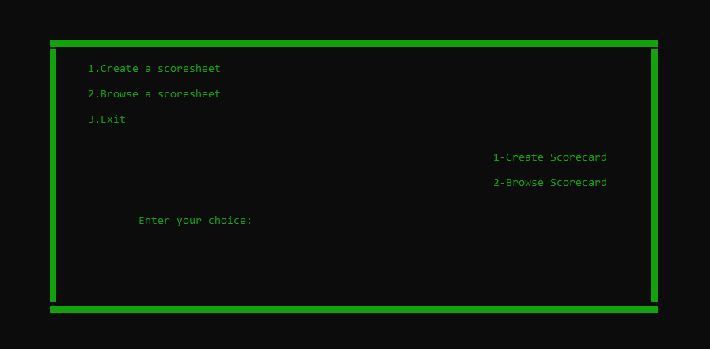

**1.2 Menu_2**

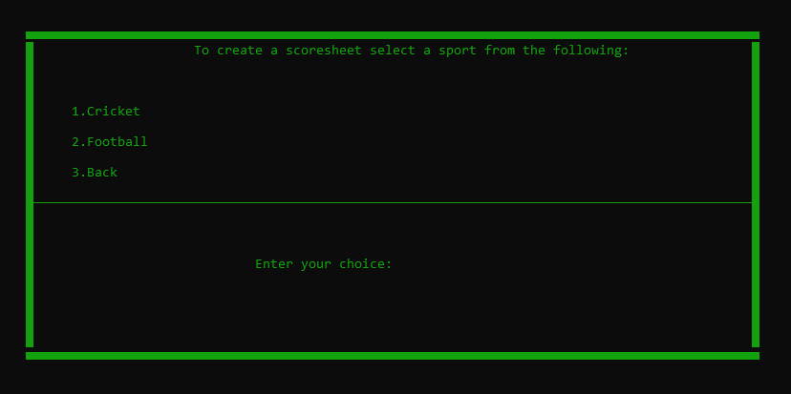

**1.3 Game details (cricket)**

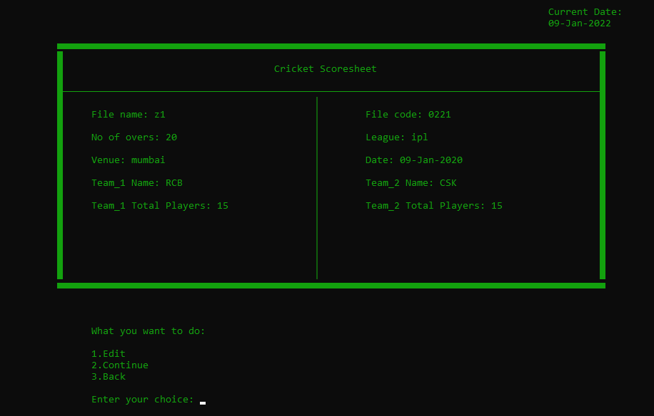

**1.4 Players details (cricket)**

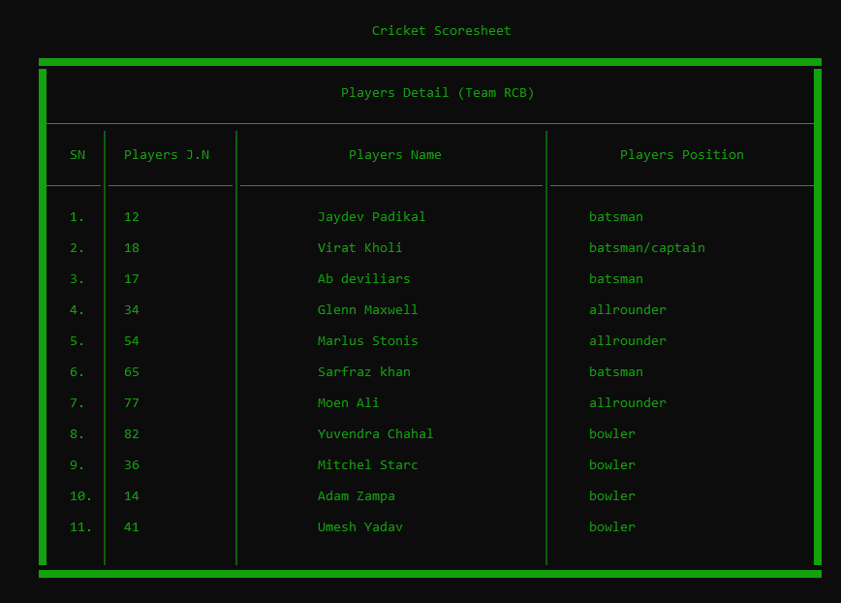

**1.5 Scoresheet_1 (cricket)**

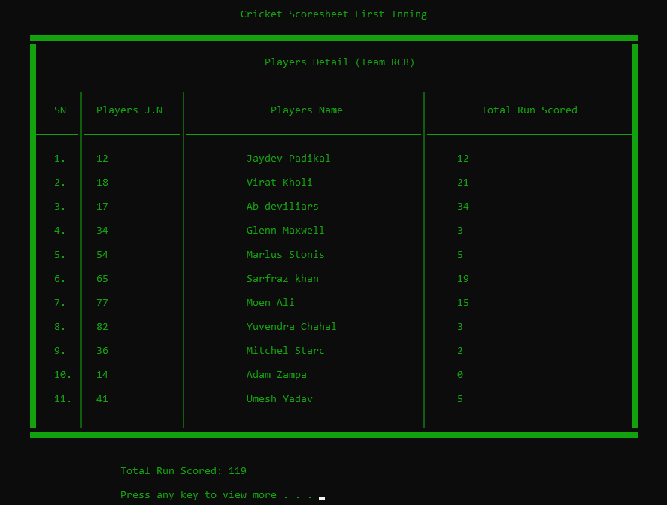

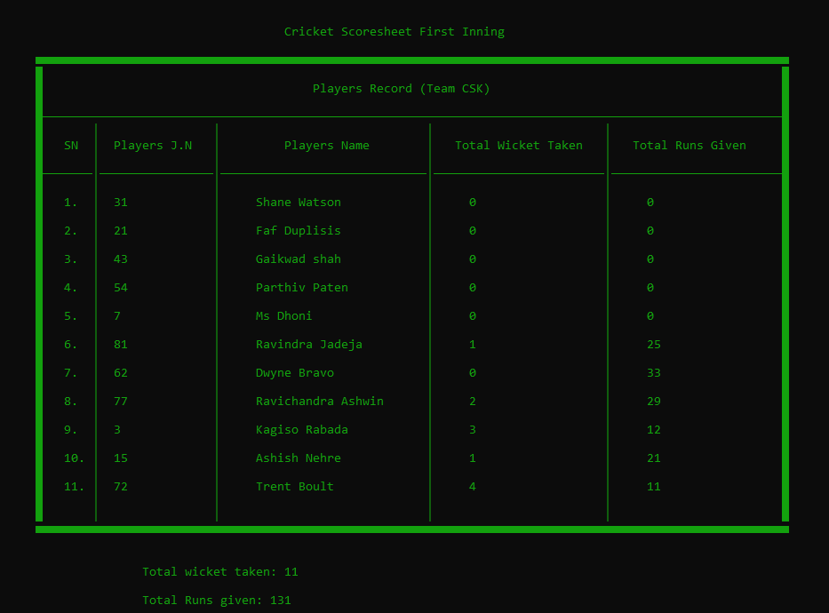**1.6 Scoresheet_2 (cricket)**

**1.7 Match Summary (cricket & football)**

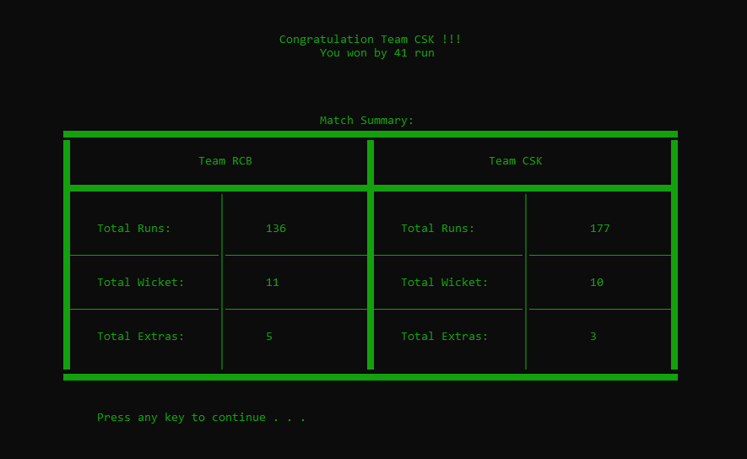

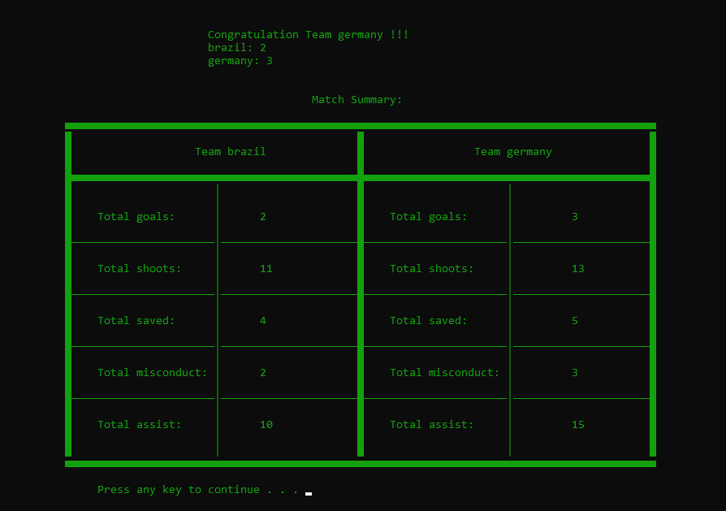

**APPENDIXES 2**

**2.1 Gantt Chart**

|  |  |  |  |  |  |  |
| --- | --- | --- | --- | --- | --- | --- |
| Task Name | 2021 | | | | | |
| **June 1** | **July 1** | **Aug 1** | **Sep 1** | **Oct 1** | **Nov 1** |
| Planning |  |  |  |  |  |  |
| Concept submission |  |  |  |  |  |  |
| Research and analysis |  |  |  |  |  |  |
| Design |  |  |  |  |  |  |
| Algorithm/Flowchart |  |  |  |  |  |  |
| Coding |  |  |  |  |  |  |
| Debugging and Testing |  |  |  |  |  |  |
| Documentation |  |  |  |  |  |  |